**Assigned Task:**

Research on the Battery Management System to be implemented in the Autonomous Vehicle.

**Purpose:**

To create a prototype initially before trying to replicate a fully functional Autonomous

Vehicle.

**Tools/Software used:**

* <http://www.youtube.com/>, <http://www.coursera.org/>

**Progress:**

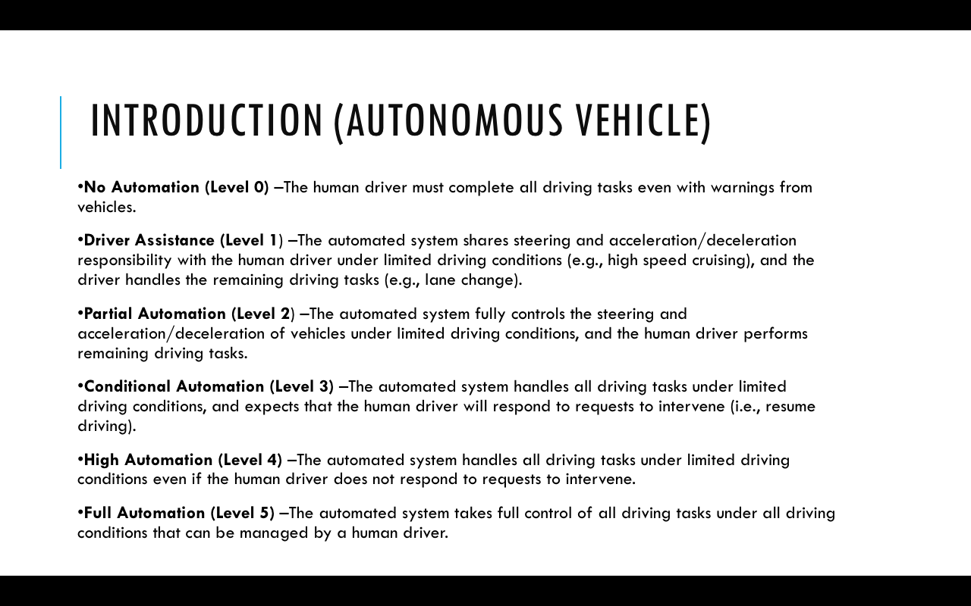

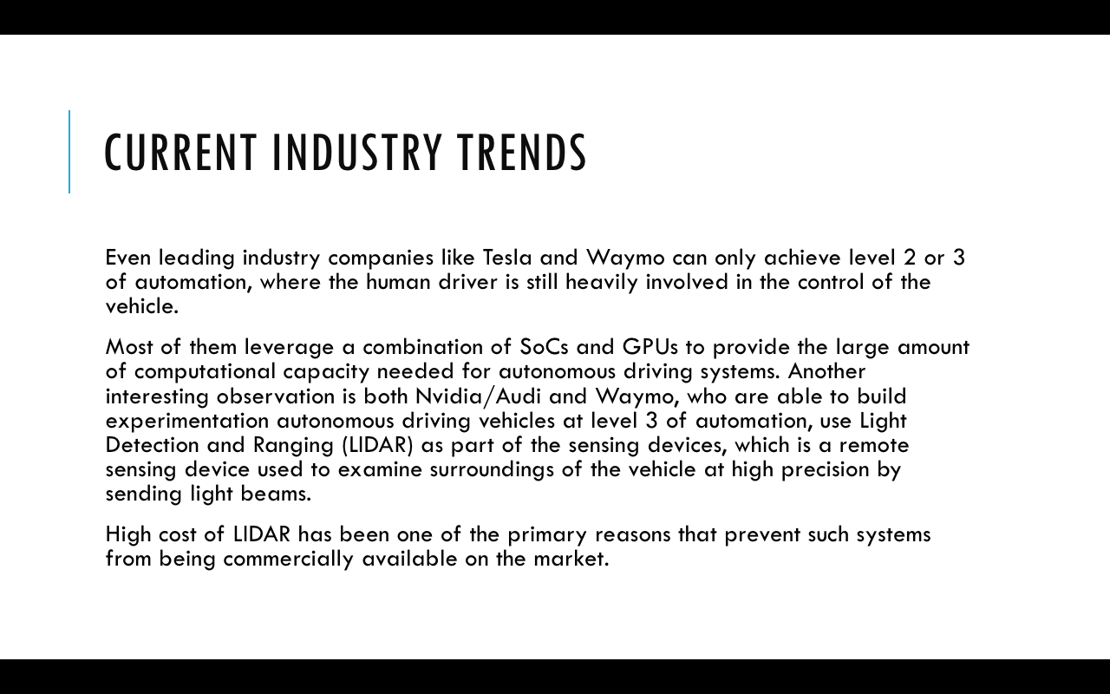

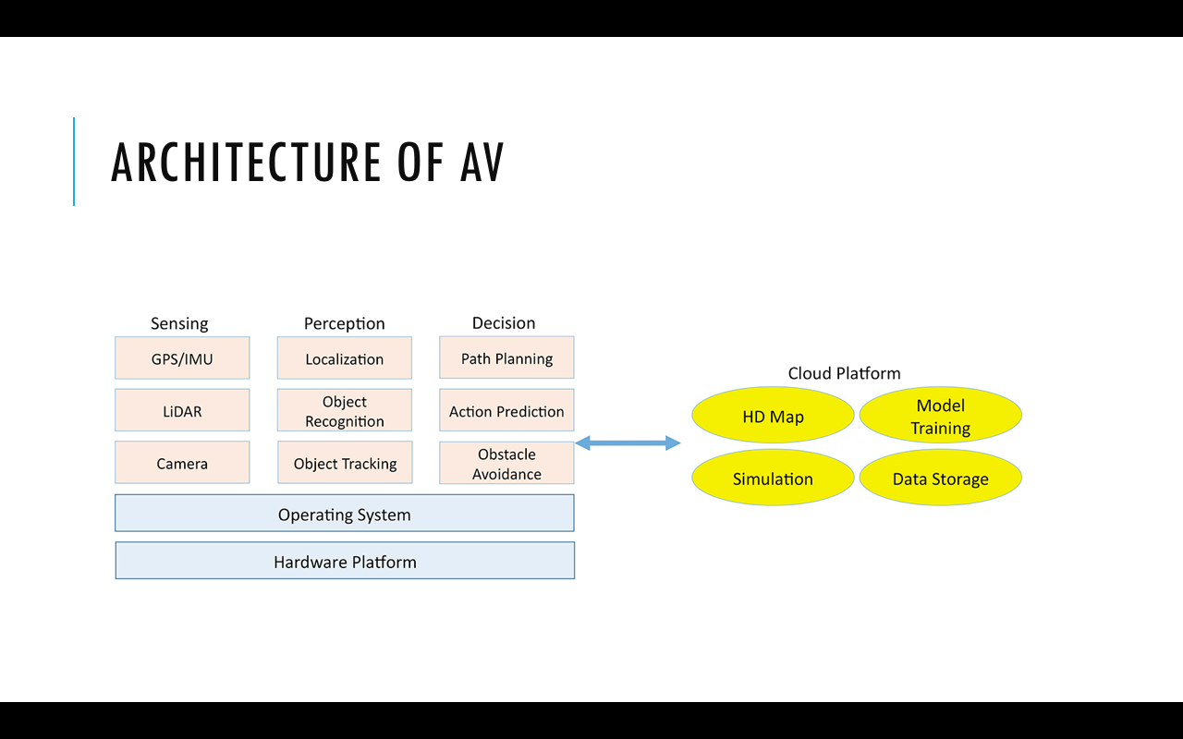

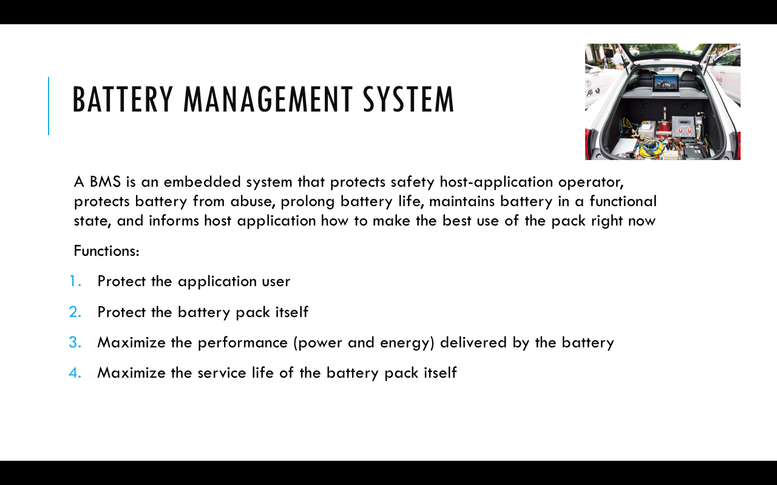

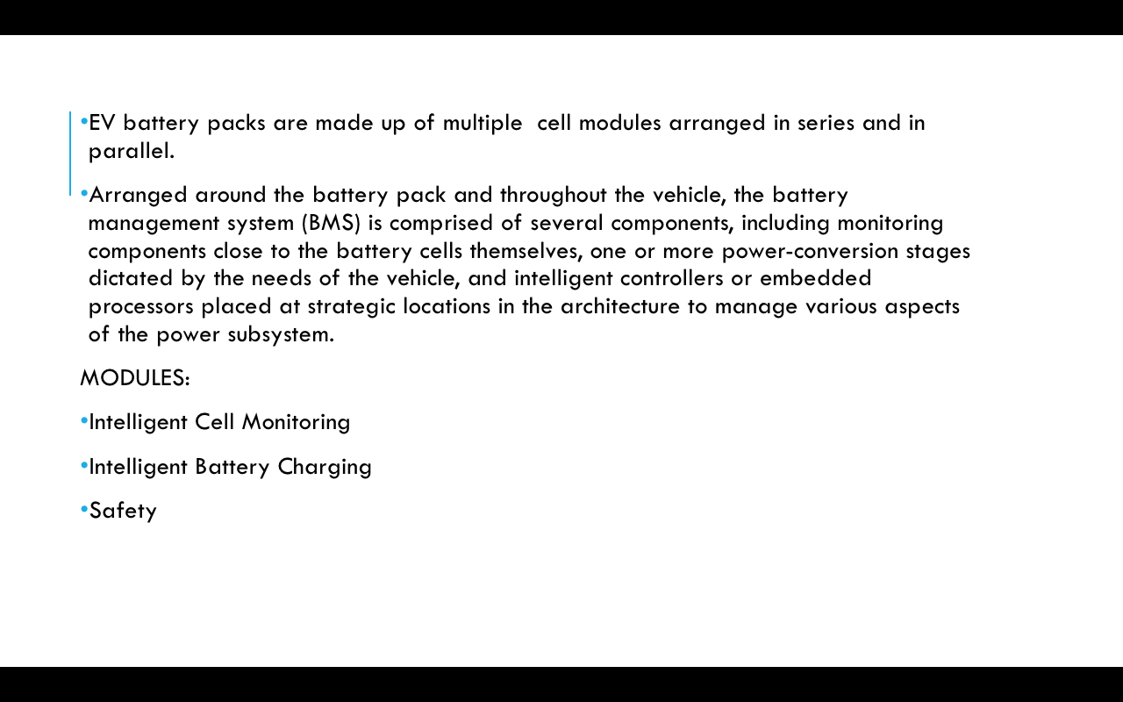

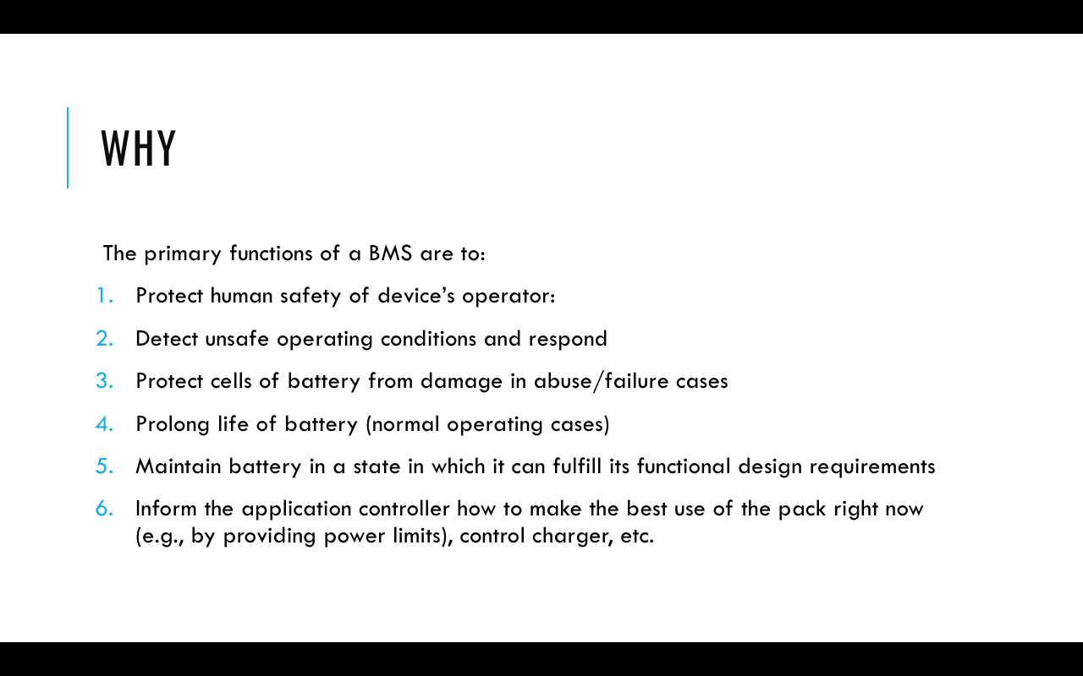

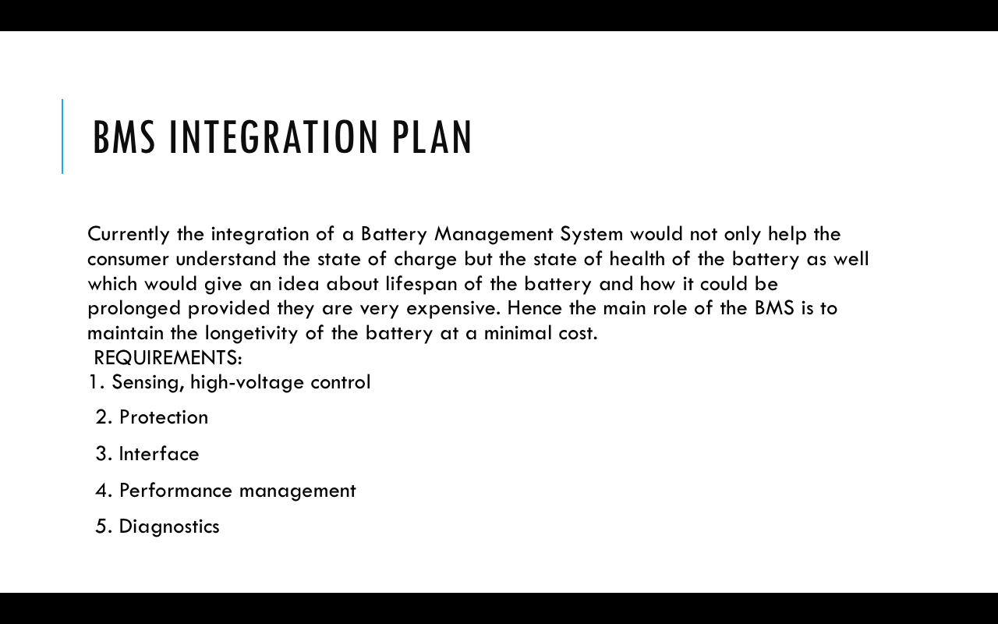

Progress for this sprint: 50%

Issues: Not yet raised

Plan made:

1. Implement sensing modules to basic battery structure (voltage, current, temperature).
2. Investigate on interconnections and formulation of battery capacity based on the power requirement of the entire vehicle.
3. List of requirements for the prototype(BMS requierments only).

.

**Prepared By:**

**Kush Jain**